Images / 圖片 | Captions | 說明
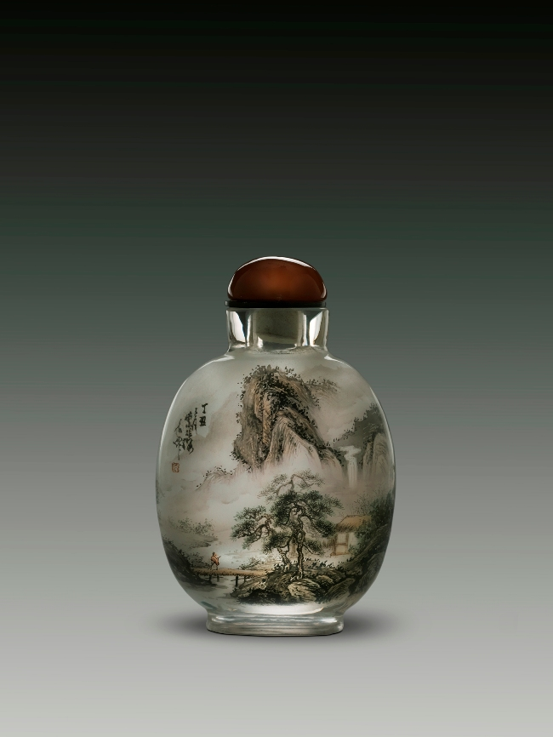 | Landscapes in Four Seasons-Winter  H: 7.2 cm  W: 5.2 cm  Glass  1997  Hong Yuan Collection | 《四季山水之冬》  高：7.2釐米  腹寬：5.2釐米  造晶  1997  鴻遠閣藏品
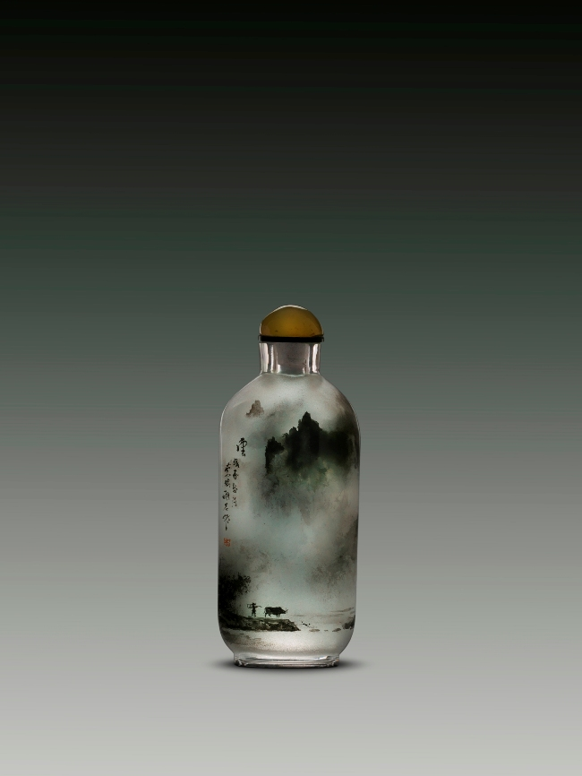 | Clouds  H: 6.7 cm  W: 3 cm  Glass  1978  Hong Yuan Collection | 《雲》  高：6.7釐米  腹寬：3釐米  造晶  1978  鴻遠閣藏品
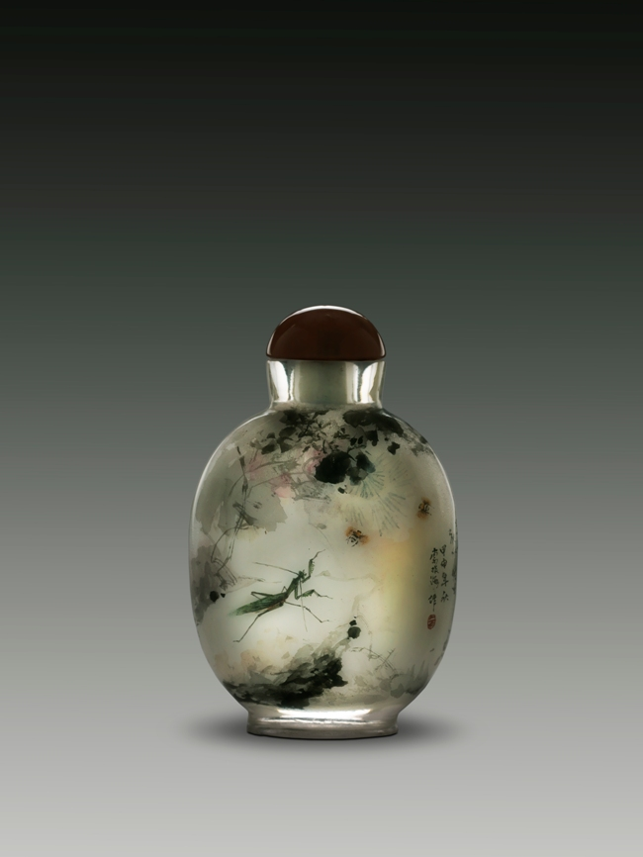 | Insects Thriving among Plants  H: 6.8 cm  W: 3 cm  Glass  2004  Hong Yuan Collection | 《草間野趣》  高：6.8釐米  腹寬：3釐米  造晶  2004  鴻遠閣藏品
 | Visiting a Friend  H: 6.8 cm  W: 3 cm  Glass  1990  Hong Yuan Collection | 《訪友》  高：6.8 釐米  腹寬：3釐米  造晶  1990  鴻遠閣藏品
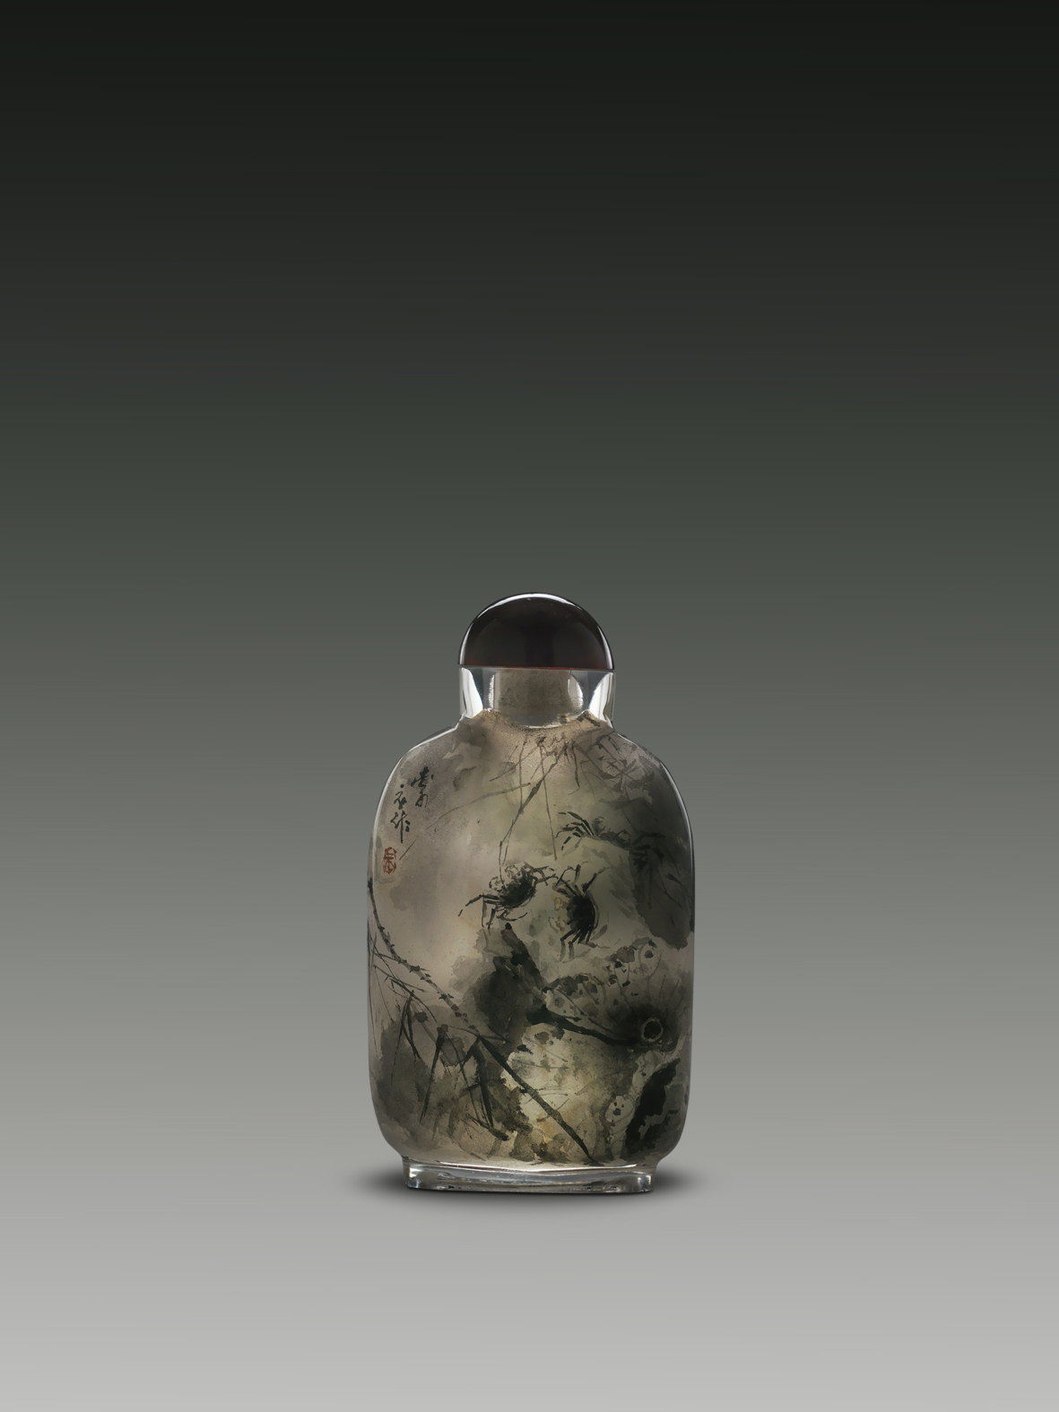 | Playful Crabs in a Lotus Pond  H: 5.8 cm  W: 3.7 cm  Glass  Hong Yuan Collection | 《荷塘戲蟹》  高：5.8釐米  腹寬：3.7釐米  造晶  鴻遠閣藏品
 | Paradise of Cloudy Mountains  H: 5.7 cm  W: 5 cm  Quartz  2003  Hong Yuan Collection | 《雲山勝境》  高：5.7釐米  腹寬：5釐米  髮晶  2003  鴻遠閣藏品
 | Scroll Painting of the Upper River during the Qing Ming Festival  H: 7.5 cm  W: 5.8 cm  Glass  Hong Yuan Collection | 《清明上河圖》  高：7.5釐米  腹寬：5.8 釐米  造晶  鴻遠閣藏品

